Test environments =

Windows 10 – Chrome, Firefox, Edge

Mac OS – Safari

Android Mobile OS – Chrome

iPhone Mobile OS – Safari

PHP 5.4

Database MySQL

Web server – Apache

Process to install =



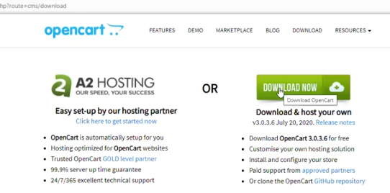

Zip file will be downloaded



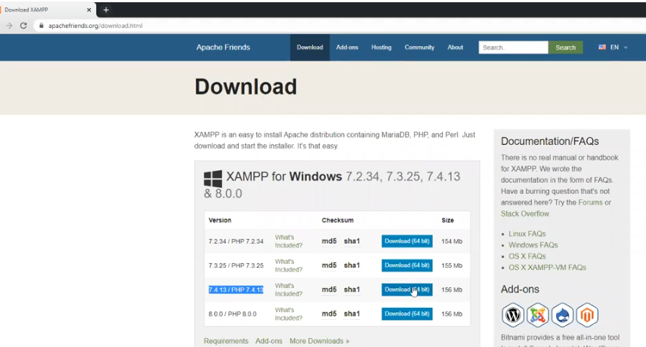

Installing xammp =

Right click on downloadable xammp file – run as administrator – click yes – ok – next – finish

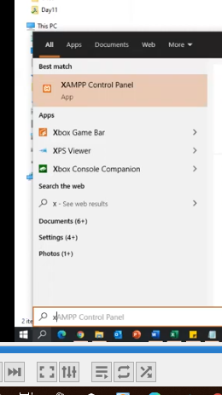

xampp control panel – run as administrator

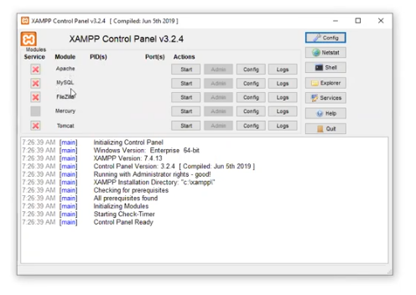

Start stop process when u want

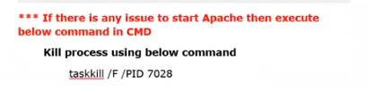

Extract opencart zip file

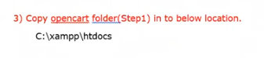

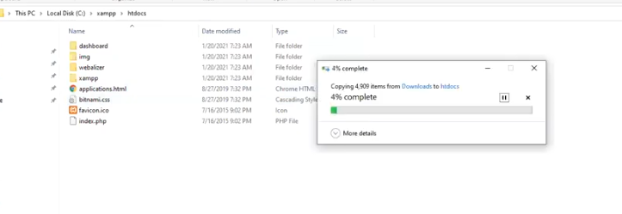

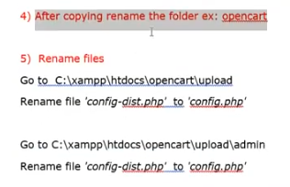

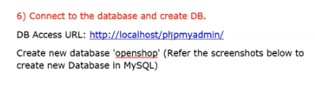

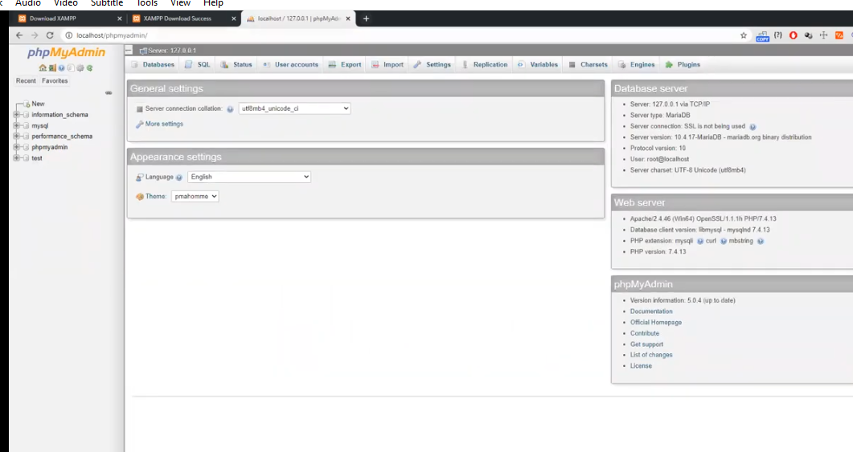

Click new – give name to database – select collation – click create – database created



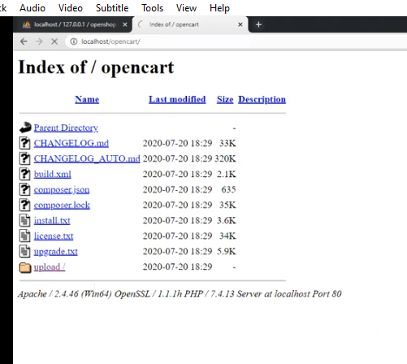

Click on upload

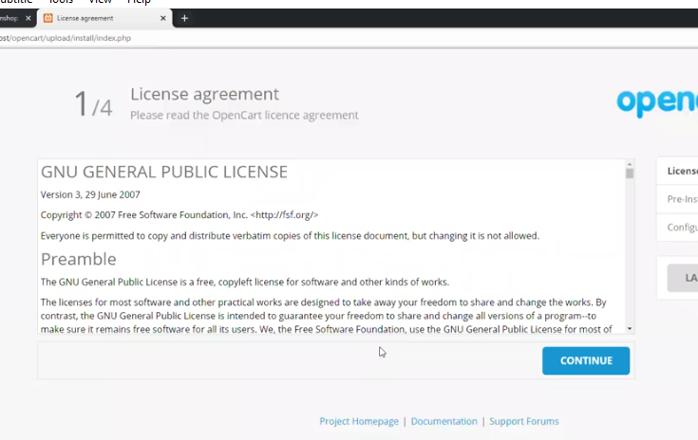

Click continue

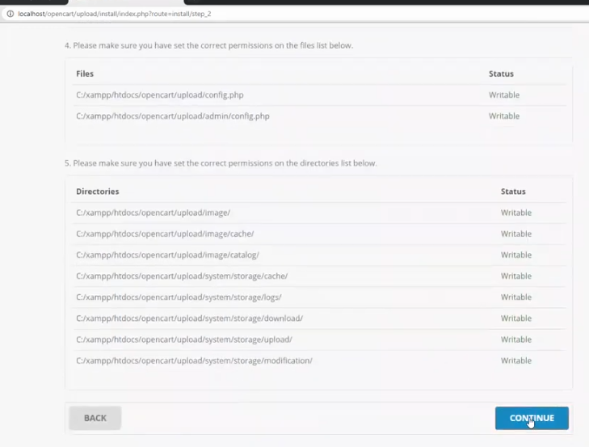

Continue

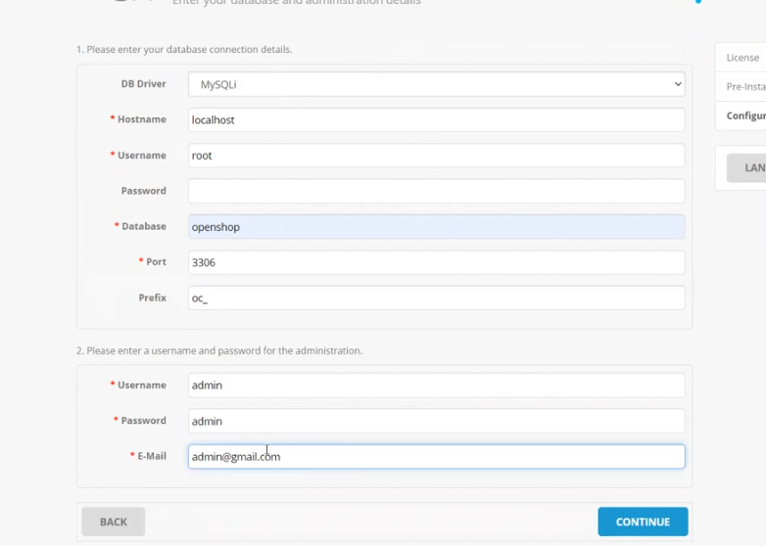

Continue

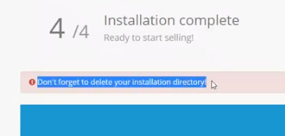





Click on go to your online shop

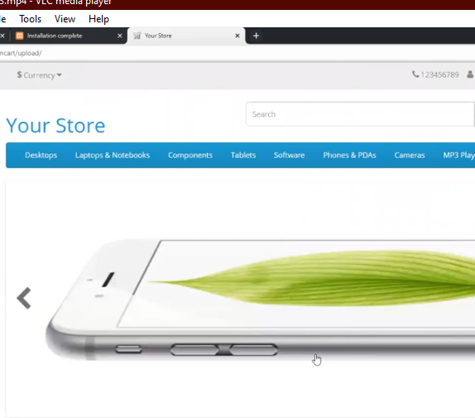

Now you are able to test this application

